Complete and submit this form, along with a U.S. Soccer Referee Report, to the appropriate competition authorities (e.g., local league, tournament director, cup coordinator, etc.) as directed for the dismissal of team officials, sending-off offenses, serious injuries, game abandonment or other substantial occurrences. For instances of referee assault or referee abuse, complete and submit this form, along with a U.S. Soccer Referee Report, to the appropriate competition authorities (e.g., local league, tournament director, cup coordinator, etc.), State President with jurisdiction for the competition and State Referee Administrator.

Home Team: Score:
Away Team: Score:
Association/League:
Division/Age Group:
Game Number:
Game Date:

Statement:

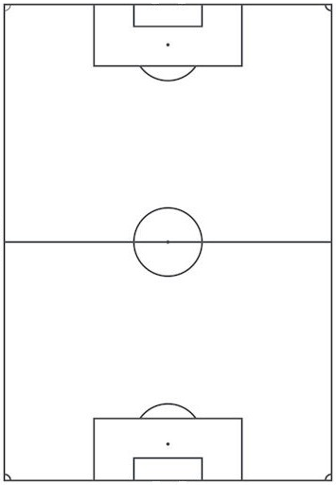

Name: Date:
USSF ID Number:
Phone Number:
Email Address:

